Asignment Deadline Manager C++

Pascal¹, Asanka², Satrio Hady Pamungkas³
Faculty of Mathematics and Natural Sciences
Universitas Gadjah Mada
Yogyakarta, Indonesia
@email

Abstract— University students often handle many assignments from different courses and lecturers, and it is hard to decide which one to work on first. Therefore, this mini project aims to help students with their assignment deadlines using a C++ program, namely the Assignment Deadline Manager. With this program, the users are asked to input some information, for example, assignment name, the days until the deadline, whether deep analysis is needed, and the number of tasks. Assignment priority is based on the due date and the volume of the tasks, and the program calculates an urgency score to determine the classification of each assignment (RED, YELLOW, and GREEN). In this program, the users can also see all of their assignments that have been added, warns the users who delay an assignment, and display motivational quotes when the assignment is completed. The program uses structures, arrays, and conditional statements that are covered in our programming course. This program has a main limitation in data storage. The data is not stored in a file, so the assignments are lost when the program is closed. Adding file storage is planned.
Keywords—deadline management, task prioritization, urgency scoring, students

Introduction
Time management is important in university life. Students come from different study programs and take courses with different lecturers, and each lecturer sets their own assignments and deadlines. Therefore, many students struggle to manage their time so that every assignment is completed on time. Research shows that prioritization, which means ranking tasks by importance and deadline, is a key part of managing academic responsibilities [1]. When students forget an assignment or miss the assignment deadline, they may lose points or even fail the course.One of the main obstacles is deciding which assignment to work on first. Prioritizing assignments, It is hard to decide which assignment to do first when there are many tasks with different deadlines.
To address this issue, we developed a C++ program that helps students track their assignments, identify which ones are urgent, and categorize them by urgency level. The objective of this project is to classify each assignment as high, moderate, or low priority. This project has limitations because it was built using only the material taught in our programming class. The program cannot store data in a file because we have not yet learned (ofstream) and (ifstream). After the program is closed, the assignments that were entered cannot be reopened, and the program only gives suggestions based on the deadlines and the urgency level entered during the current run. Adding file storage is part of our future development.

Related Work

Selecting a Template (Heading 2)
First, confirm that you have the correct template for your paper size. This template has been tailored for output on the US-letter paper size. If you are using A4-sized paper, please close this file and download the file “MSW_A4_format”.

Maintaining the Integrity of the Specifications
The template is used to format your paper and style the text. All margins, column widths, line spaces, and text fonts are prescribed; please do not alter them. You may note peculiarities. For example, the head margin in this template measures proportionately more than is customary. This measurement and others are deliberate, using specifications that anticipate your paper as one part of the entire proceedings, and not as an independent document. Please do not revise any of the current designations.

Methodology

Data Structure
Each assignment is stored in a struct containing its name, days left, number of tasks, deep analysis flag, urgency label, completion status, and delay count. Up to 100 assignments are kept in an array.

Urgency Scoring
The total score is classified as Red (high urgency) above 70, Yellow (moderate) from 40 to 70, and Green (low) below 40.

Factor | Condition | Points
Time | 1 - 3 days left | 50
Time | 4 - 7 days left | 30
Time | More than 7 days | 10
Analysis | Need deep analysis | 25
Volume | More than 5 tasks | 25
Volume | 3 - 5 tasks | 15
Volume | less than 3 | 10
Table I

Delay Count
Delaying increases the counter by one, and a warning is displayed when the assignment has been delayed three times or more. Finishing marks the assignment as completed and displays a quote based on the days left.Quotes by days

Option | Action | Effect
Make progress | Work on the assignment | Delay counter reset to 0
Delay it | Postpone the assignment | Delay counter increases by 1
Finish | Mark as done | Quotes shown
Table II

Quotes by days left
As an additional feature, the program displays a motivational quote when the user completes an assignment. The quote depends on how many days were left at that time, as shown in the table below.

Days Left | Quote
7 or more | It always seems impossible until it's done
5 - 6 | The secret of getting ahead is getting started
3 - 4 | Quality is not an act, it is a habit
1 - 2 | Well done is better than well said
Equal 0 | The only way to do great work is to love what you do
Other | Success is not final, failure is not fatal: it is the courage to continue that counts
Table III

Flowcharts
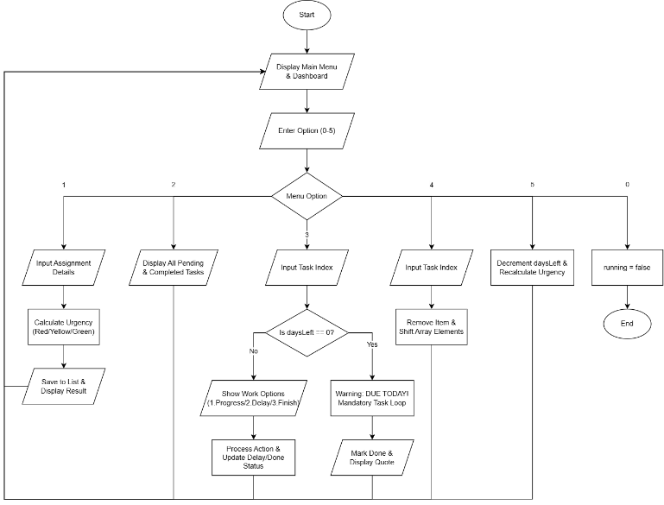

Implementation
After the text edit has been completed, the paper is ready for the template. Duplicate the template file by using the Save As command, and use the naming convention prescribed by your conference for the name of your paper. In this newly created file, highlight all of the contents and import your prepared text file. You are now ready to style your paper; use the scroll down window on the left of the MS Word Formatting toolbar.

Authors and Affiliations
The template is designed for, but not limited to, six authors. A minimum of one author is required for all conference articles. Author names should be listed starting from left to right and then moving down to the next line. This is the author sequence that will be used in future citations and by indexing services. Names should not be listed in columns nor group by affiliation. Please keep your affiliations as succinct as possible (for example, do not differentiate among departments of the same organization).

For papers with more than six authors: Add author names horizontally, moving to a third row if needed for more than 8 authors.

For papers with less than six authors: To change the default, adjust the template as follows.

Selection: Highlight all author and affiliation lines.

Change number of columns: Select the Columns icon from the MS Word Standard toolbar and then select the correct number of columns from the selection palette.

Deletion: Delete the author and affiliation lines for the extra authors.

Identify the Headings
Headings, or heads, are organizational devices that guide the reader through your paper. There are two types: component heads and text heads.
Component heads identify the different components of your paper and are not topically subordinate to each other. Examples include Acknowledgments and References and, for these, the correct style to use is “Heading 5”. Use “figure caption” for your Figure captions, and “table head” for your table title. Run-in heads, such as “Abstract”, will require you to apply a style (in this case, italic) in addition to the style provided by the drop down menu to differentiate the head from the text.
Text heads organize the topics on a relational, hierarchical basis. For example, the paper title is the primary text head because all subsequent material relates and elaborates on this one topic. If there are two or more sub-topics, the next level head (uppercase Roman numerals) should be used and, conversely, if there are not at least two sub-topics, then no subheads should be introduced. Styles named “Heading 1”, “Heading 2”, “Heading 3”, and “Heading 4” are prescribed.

Figures and Tables

Positioning Figures and Tables: Place figures and tables at the top and bottom of columns. Avoid placing them in the middle of columns. Large figures and tables may span across both columns. Figure captions should be below the figures; table heads should appear above the tables. Insert figures and tables after they are cited in the text. Use the abbreviation “Fig. 1”, even at the beginning of a sentence.
- Table Type Styles
Table Head | Table Column Head
Table Head | Table column subhead | Subhead | Subhead
copy | More table copyª
- Sample of a Table footnote. (Table footnote)
We suggest that you use a text box to insert a graphic (which is ideally a 300 dpi TIFF or EPS file, with all fonts embedded) because, in an MSW document, this method is somewhat more stable than directly inserting a picture.
To have non-visible rules on your frame, use the MSWord “Format” pull-down menu, select Text Box > Colors and Lines to choose No Fill and No Line.
- Example of a figure caption. (figure caption)
Figure Labels: Use 8 point Times New Roman for Figure labels. Use words rather than symbols or abbreviations when writing Figure axis labels to avoid confusing the reader. As an example, write the quantity “Magnetization”, or “Magnetization, M”, not just “M”. If including units in the label, present them within parentheses. Do not label axes only with units. In the example, write “Magnetization (A/m)” or “Magnetization {A[m(1)]}”, not just “A/m”. Do not label axes with a ratio of quantities and units. For example, write “Temperature (K)”, not “Temperature/K”.

Result And Discussion
Lorem ipsum

Conclusion And Future Work
The preferred spelling of the word “acknowledgment” in America is without an “e” after the “g”. Avoid the stilted expression “one of us (R. B. G.) thanks ...”. Instead, try “R. B. G. thanks...”. Put sponsor acknowledgments in the unnumbered footnote on the first page.

References

[1] J. T. Calonia et al., "Time management and academic achievement: Examining the roles of prioritization, procrastination and socialization," Int. J. Innov. Sci. Res. Technol., vol. 8, no. 6, pp. 766-772, Jun. 2023. [Online]. Available: https://files.eric.ed.gov/fulltext/ED647441.pdf

IEEE conference templates contain guidance text for composing and formatting conference papers. Please ensure that all template text is removed from your conference paper prior to submission to the conference. Failure to remove template text from your paper may result in your paper not being published.

